SOUND
- Two major classes of waves are longitudinal and transverse. Sound waves are

longitudinal | transverse

- The frequency of a sound signal refers to how frequently the vibrations occur. A high-frequency sound is heard at a high

pitch | wavelength | speed

The sketch below shows a snap shot of the compressions and rarefactions of the air in a tube as the sound moves toward the right. The dots represent molecules.
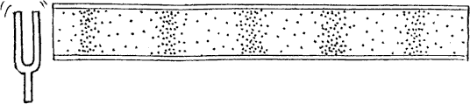

- Using the ruler provided, the wavelength of the sound wave is measured to be

- Compared to the wavelengths of high-pitched sounds, the wavelengths of low-pitched sounds are

long | short

- Sound waves travel fastest in

solids | liquids | gases | ... the same speed in each

- The accepted value for the speed of sound in air is 331 m/s at 0ºC. The speed of sound in air increases 0.6 m/s for each Celsius degree above zero. Compute the speed of sound at the
temperature of the room you are now in.
Refer to the following information for the next two questions.

Suppose you set your watch by the sound of the noon whistle from a factory 3 km away.

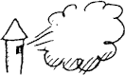

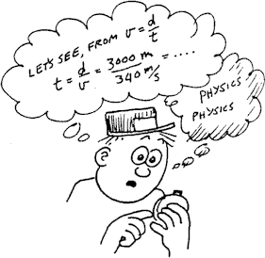
- Compared to the correct time, your watch will be

- It will differ from the correct time by

3 seconds | 6 seconds | 9 seconds

Refer to the following information for the next four questions.

Suppose a child's natural frequency of swinging is once each 4 seconds.
- For maximum amplitude the man should push at a rate of once each

2 seconds | 4 seconds | 8 seconds

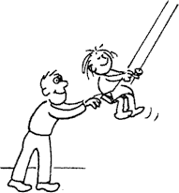
- If the man in previous question pushes in the same direction twice as often, his pushes

will be effective | will not be effective

because

the swing will be pushed twice as often in the right direction
every other push will oppose the motion of the swing

- Based on this swing example, a 440 hz- tuning fork could NOT be forced into vibration by a sound of

220 hz | 440 hz | 880 hz

Refer to the following information for the next three questions.

Two notes with frequencies of 66 and 70 hertz are "sounded together."

- The resulting beat frequency is

4 hertz | 68 hertz | 136 hertz

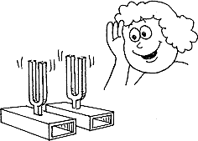
at a pitch of

4 hertz | 68 hertz | 136 hertz

- Beats are the result of the alternate cancellation and reinforcement of two sound waves of

the same frequency | slightly different frequencies

